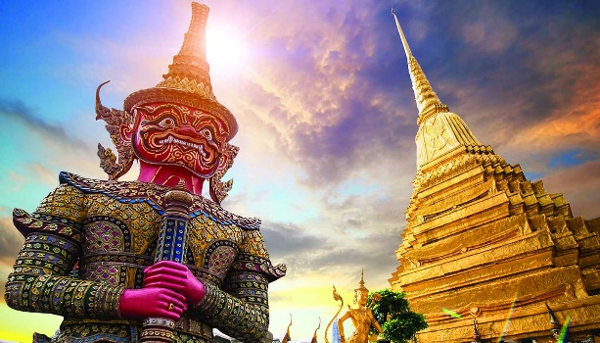
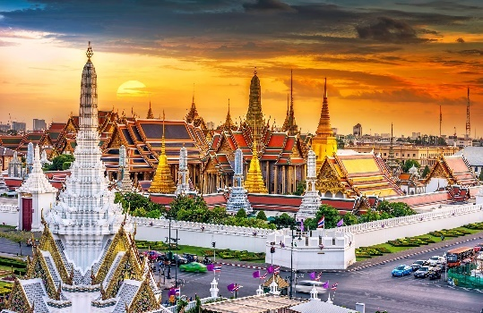
LOGISTICS NOTE
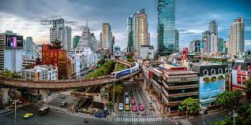
VENUE INFORMATION

The 2022 APEC Business Ethics for SMEs Forum will take place at the W Hotel Bangkok from 12-13 September, 2022. The hotel is located at 106 North Sathon Road, Silom, Bang Rak, Bangkok 10500, Thailand. The W Hotel is a venue for major events in the capital city.

GUEST ROOM RESERVATIONS

All delegates are responsible for making their own guest room reservations and should do so as soon as possible. Delegates are encouraged to stay at the W Hotel. Make hotel reservations using this website link: Link forthcoming

Alternatively, attendees may be able to make hotel reservations using a travel agency or a third-party hotel booking website. Please note that nightly guest room rates are subject to change and availability. Additional accommodations within a 10 minute driving distance include The Athenee Hotel, Royal Orchid Sheraton Hotel & Towers, Conrad Bangkok, and Millennium Hilton Bangkok.

All delegates are responsible for making their own lodging arrangements.

AIRPORT TRANSFERS

Taxis are the most convenient way to transfer from the Bangkok's Suvarnabhumi Airport (BKK). Upon exiting customs, participants should follow the signs to the public taxi stand located on Level 1 (Ground Level) near entrances 3, 4, 7 and 8. Once there, participants will receive a ticket from a taxi queue machine and proceed to the lane number printed on the ticket. Taxi fares are metered with a 50 Baht airport surcharge, in addition to expressway fees. Public, official taxis will be yellow and black vehicles.

Ride-hailing apps, including Uber and Grab, are also operational in Bangkok.

Participants looking for other modes of transportation from the airport may consider the Airport Rail Link.

Bangkok is prone to traffic jams, so please plan accordingly.

ARRIVAL INFORMATION AND BADGE COLLECTION

Please register for the Forum using this link. Please note your name will be displayed on your name badge and participant list exactly as entered in the online registration form.

Badges may be collected at the following times and locations:
- Sunday, 11 September: 16:00 – 17:00, Great Room, W Hotel Bangkok
- Monday, 12 September: 7:30 – 8:30, Great Room, W Hotel Bangkok
- Tuesday, 13 September: 8:00 – 9:00, Great Room, W Hotel Bangkok

Delegates arriving into Bangkok on Sunday, 11 September are encouraged to pick up registration materials from 16:00 to 17:00 to avoid long registration lines on Monday, 12 September.

VISAS

Ordinary passport holders from China, Mexico, Papua New Guinea, and Chinese Taipei are required to secure a visa prior to entry into Thailand. Visa applications should be submitted to your local Thailand consular office at the earliest possible time to allow for sufficient processing. Official/Diplomatic passport holders from these and other APEC economies may also require a visa and should inquire with your local Thailand consular office to confirm entry requirements. If the local consular office in your economy requests additional materials to process your application, please email apecethics@crowell.com for assistance. Delegate registrations must be submitted online before assistance can be provided with visa materials.

Delegates from other economies are not required to obtain a visa when entering Thailand and qualify for the Tourist Visa Exemption Scheme under the following conditions:
- Proof of possession of $700 USD / 20,000 Bhat per person
- Certificate of vaccination or an RT-PCR / Professional ATK COVID-19 test result issued within 72 hours of departure

*As of 1 July 2022, the Thailand Pass is not required for Thai and Foreign Nationals.
Thailand Pass Registration System (for air travel only) (consular.go.th)

HEALTH

As of June 23, 2022, mask wearing in public in Thailand is now voluntary, however individuals are encouraged to wear masks in high-risk settings. There are no curfew requirements related to COVID-19.

Same-day COVID-19 testing is available at most private hospitals throughout Thailand. For the current list of COVID-19 testing cost and locations approved by the Thailand Ministry of Public Health, please use this link.

Vaccinated delegates must have the following documents for entry into Thailand:
- A valid passport, or a border pass for arrivals
- A certificate of COVID-19 full vaccination with an approved vaccine (including Pfizer, Moderna, AstraZeneca, Sinovac, Sinopharm)

Unvaccinated delegates must have the following documents for entry into Thailand:
- A valid passport, or border pass for arrivals
- A negative result from an RT-PCR test or professional ATK within 72 hours of travel

LANGUAGE

The event will be conducted in English.

DRESS ATTIRE

Requested attire for the Forum is business dress.

LUNCH / REFRESHMENTS

Lunch will be offered onsite during both days as a convenience to attendees. It is not recommended that participants make lunch arrangements offsite during the Forum. Coffee, tea, and light refreshments are provided during designated networking breaks.

PARKING / GROUND TRANSPORTATION

Participants are encouraged to utilize mass transit, ride sharing, or taxi service. Those wishing for expeditious arrival and departure to the venue each day can arrange a private car service (drop-off and pick-up) with the W Hotel concierge.

INTERNET ACCESS

There will be free wireless internet access throughout the event. Please see posted signs for network and access code details.

WEATHER

September is the summer season in Bangkok and is typically a rainy month. The average high temperature in September is 32 degrees Celsius (91 degrees Fahrenheit) and the average low temperature is 25 degrees Celsius (77 degrees Fahrenheit.) Delegates are advised to bring light clothing and an umbrella.

TOURISM

Delegates interested in planning tourist activities in Thailand before and/or after the Forum are encouraged to visit the Official Site of Thailand Travel sponsored by the Tourism Authority of Thailand for more information.

CONTACT INFORMATION FOR GENERAL INQUIRIES

Business Ethics for APEC SMEs Stakeholder Liaison Telephone: +1-202-508-8764 or +1-202-508-8881.
Inquiries: apecethics@crowell.com

